Class diagram

(pic here)

Map of the environment

(pic here)

(domain of the environment: 4000*4000 square plane)

Handling collision(unused)

<https://answers.unrealengine.com/questions/193112/handling-collisions-with-c.html>

Handle specific collision settings?(unused)

PI sics8a118P 
File Edit Asset View 
Debug Window 
Blueprint Props 
Help 
Simulation 
Parent class: 
Defaults > 
Pawnh 
Component 
Compile Save 
components 
Find in CB 
Add Component 
• Class 
(ROOT] Ball 
yspringArm 
•vCamera 
Start Awake 
Locked Axis 
Colfision 
Simulation Generates Hit Events 
Generate Overlap Events 
Asset 
BallMesh 
Default 
Custom... 
Collision Enabled 
Player 
Ignore Overlap 
View 
Project settings 
Project 
Movies 
gypp„ 
Taro- . Hardware 
Engine 
Audio 
Collision 
Console 
Cooker 
Export... 
Grap 
Import.. 
Collision Presets 
Collision Enabled 
Object Type 
Collision Respmses 
Trace Responses 
Visibility 
Camera 
Object Responses 
WorldStatic 
WorldDynamic 
Pawn 
PhysicsBody 
Vehicle 
Block 
O 
Engine - Collision 
Set up and modify collision settings. 
These settings are saved in DefaultEngine.ini, which is currently writable. 
Object Channels 
You can have up to 18 custom channels including object and trace 
channels. This is list of object type for your project. If you delete the object 
type that has been used by game, it will go back to WorldStatic. 
New Object Channel. 
Edit.. 
Delete 
Name 
Player 
Default Response 
BIOCk 
Block 

a* search algorithm working flow with tree visualization

[Step-by-Step: A Star Search](https://www.youtube.com/watch?v=sAoBeujec74)

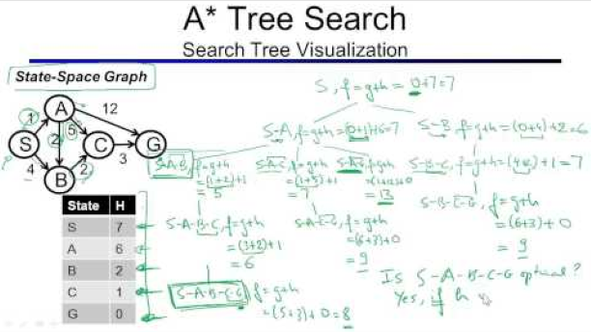

Extending enum value(can't used, placed it in to the parent class)

<https://stackoverflow.com/questions/644629/base-enum-class-inheritance>

Refreshing content browser

<https://www.reddit.com/r/unrealengine/comments/6wdfya/quick_question_how_to_updaterefresh_content/dm779i2/?depth=1>

Spawning actors with parameters

<https://answers.unrealengine.com/questions/284744/spawning-an-actor-with-parameters.html>

Properties of Prioity queue

<https://en.cppreference.com/w/cpp/container/priority_queue>

Getting actor's raw pitch roll

<https://answers.unrealengine.com/questions/673541/how-to-get-actor-pitch-and-yaw-using-c.html>

Struct=>a mini class of a class

Coding strategy

* Using a kanban to control the current job
* Huge Laziness always stopping my progres
* Setting Up a base creature class and node class, as it's necessary
* Then create functions for it
* Create a path node base class, for the base of the food pallet and the shelter(but they does the different job.)
* Create a a*pathfinding class to make maneuverable, nonlinear route

Things to concern

* a* workflow
  + How template programming could work? Map? Queue?
  + A NodeCost struct used to make a tree list(var: node, parent node, cost, heuristic)
  + Array:
    - Frontier(queue that priotize the top as the lowest total cost),
    - closedNode(array that contains the node that's expanded)
    - processed node(all node cost object contains to prevent memory leakage)
  + Algorithm
* Mesh pointing direction=>(Fvector).Rotation
  + Maybe the problem of the wedge mesh, it needs to rotate Z 90degrees more in order to point at a proper direction.
* How to set custom (mesh).object or bounding box for physic stuff?
  + Give up, focus on wedge only.
* How to determine the unit of distance in visual
  + 1.0f=1cm
  + And also the wedge size=>1m
  + Random position domain ensuring=>detect is it have object by sweep OR doing in a binary table
* Generate pallet=>in a specific generator's tick function.
* Search nodes and paths=> using a pathfind actor to manage all of that thing.

How to collect all nodes?

* path node static array for it?(tried but quite dodgy)
* Final method: the pathfinder find all of it since begin of the play

Issues

* Keep crashing by unknown reason
  + After traced, it's the null pointer issue that break the game
  + And the path list index issue
    - Solved by awaring the array index position
* Need duplicating pathfinder class
  + Can I just keep it in 1 specific actor?
    - How to grab 1 specific class from world?=>get world
    - Solved by reconstruct the pathfinding class as an actor(which grabs all path nodes) and creature class with a pointer only for that actor.
* Crashing when in 2-3rd game startup(reason unknown)
  + Due to some memory leakage which makes array becomes weird?
  + Partially solved by letting every actors delete pointers’ content they have and make it null pointers when spawned.
* Start node and end node is stuck at node 1.
  + Assume due to the find nearest node problem.
  + Reason: there's no position input.

Tactics of hunter

* If creature is in standby mode
  + Get the path and go to that target via nodes
  + If creature is moved, switch to the normal chasing
* If creature is other mode
  + Directly chase that target
* If wasted too much target, find another target by wander around again.

Flocking for gatherer?

* Still thinking…